CSCI4211: Introduction to Computer Networks

Homework Assignment II

Due 11:55 PM March 5th, 2014

Help-hot-line: csci4211-help@cs.umn.edu

Name: ___Russell Bunch Student ID:__4352554___

Important Notes:

Please submit your homework in either PDF or MS Word format using the online electronic submission system on the class moodle website. The MS Word version of this assignment can be downloaded at the moodle website, which you can edit directly. Only online submission accepted. No hard copy. All text book references pertain to the 6rd Edition. For details check the course website.

You may discuss ideas and ask for clarifications freely with others on or off the class forum, and with Professor He or with the TAs. You must not provide or accept other assistance on the assignments.

Please do not write any thing other than name and student ID on this cover page

For Teaching Assistant Only
Score of this homework:

Problem | Points | Score
1 | 12
2 | 10
3 | 10
4 | 18
5 | 10
6 | 10
7 | 30
Total | 100

1. Short Questions (12 pts, 2 pt. each)

- Explain why sometimes an application developer might choose to run an application over UDP rather that TCP (2pts.)

It will be faster as it does not have to handshake for every packet. With UDP you have:
- Finer application-level control over what data is sent, and when
- Connectionless (no handshake)
- Not connection state
- Small packer header (compared to TCP)

- Is it possible to support reliable data transfer even the application is running over the UDP and explain why? (2pts)

No. UDP does not offer anything for reliable data transfer. It has checks for consistency and integrity, but it does not care if the receiver received the packet or not and sends nonstop until the message is finished. Therefore packets can get lost in the process. However more reliability can be added to check for packet loss, but at this point TCP would be better recommended.

- What are the differences between flow control and congestions control? (2pts)

Flow control is making sure the receiver has the capacity to receive at the rate you are sending. Therefore making necessary adjustments to how many packets you send if the receiver is overloaded. Congestion control is preventing the routers and other network devices from overloading under a flood of packets.

- Describe what slow start in TCP is. (2pts.)

This is when a TCP connection begins with a small MSS. For every successful ACK, the MSS is increased by 1. Thus doubling the sending rate every RTT and giving us an exponentially increasing speed.

- Explain how TCP flow control works (2pts)

Flow control is a direct result from slow start. When the sender contacts the receiver, the receiver sends the host a window size. This is the amount of packets the receiver is willing to handle at one time. This avoids the sender from overwhelming the receiver. The receiver specifies in the received window field how many bytes it is willing to buffer. The host can only send within this buffer.

- Suppose a process in host C has a UDP socket with port number 123. Suppose host A and host B each send a UDP segment to host C with destination port number 123. Will both of these segments be directed to the same socket at host C? If so, how will the process at host C know that these segments originated from two different hosts? (2pts.)

Both packets from A and B will make it to C on port 123. This is because the UDP packet has a destination area in its header. This also supports that C will know what came from who because the packet will report whom it belongs to in the source field in the header.

2. TCP Reliable Data Transfer (10 pts)

Consider two nodes are linked by an 8Mbps link （assume 1Mbps = 1000Kbps） and RTT is 0.02 sec. Assume the size of each packet is 2K bits.

Answer the following questions for ARQ schemes:

- Assume that the link is error-free, what is the possible maximum rate of transmission for Stop-and-wait, GBN, and SR, respectively? Why? (6 pt.)

Stop & Wait:
$$T_{transmit}=\frac{\frac{2Kb}{pkt}}{8E3Kbps}=0.00025 seconds$$

$$T_{max}= \frac{2Kb}{(0.02+\left(0.00025sec\right))}= 98.765Kbps$$

GBN & SR:

Since we are not accounting for error, or rather there is no error. Both GBN & SR are the same. Assuming the window size is big enough to send packets without waiting for an ACK. The bandwidth will be used 100%, thus our max rate is 8Mbps.

- For GBN, in order to allow sender to continuously send packets without any waiting, what is the minimum window size in terms of the number of packets? (1 pt.)

The minimum window size needed to continually send packets is the total time to receive the ACK divided by the 1st packet transmission time. Therefore

$$T_{transmit}=\frac{\frac{2Kb}{pkt}}{8E3Kbps}=0.00025 seconds$$

$$T_{max}=\frac{0.00025+.02}{0.00025sec}=81 packets$$

- Suppose that we transmit 10 packets with sequence number from 1 to 10. Except the packet with sequence number 6 is lost, the rest 9 packets are received correctly. Assuming there is no ACK lost, for stop-and-wait, GBN, and SR, which packets have been retransmitted? (3 pt.)

- S&W would only retransmit packet 6. Since it waits for each ACK before moving onto the next packet, it is assumed it has received ACKs 1-5 and simply needs to receive ACK 6 before moving on.
- GBN would resend all the packets in the window. Assuming the window is of size 10, it would have to resend packets 6-10, as the window has moved over to begin at packet 6 (since ACKs 1-5 were received).
- SR would only resend packet 6. The receiver would receive 1-5:7-10. If there were more packets (assuming a window of 10 and if we had more packets), the window would move to start at 6. It would resent 6, and send 11-15.

3. TCP Sequence Numbers (10 pts.)

Host A and B are communicating over a TCP connection, and Host B has already received from A all bytes up through byte 144. Suppose that Host A then sends two segments to Host B back-to-back. The first and second segments contain 20 and 40 bytes of data, respectively. In the first segment, the sequence number is 145, source port number is 303, and the destination port number is 80. Host B sends an acknowledgement
whenever it receives a segment from Host A.

- In the second segment sent from Host A to B, what are the sequence number, source port number, and destination port number? (3pts.)

The seq # is 166 (following the 20 bytes of data), source remains the same at 303 and so does the destination at 80.

- If the first segment arrives before the second segment, in the acknowledgement of the first arriving segment, what is the acknowledgment number, the source port number, and the destination port number? (3pts.)

The ACK# is 166, source 80 and destination 303.

- If the second segment arrives before the first segment (out of order arrival), in the acknowledgement of the first arriving segment, what is the acknowledgment number? (1pt.)

Assuming this is Stop & Wait, the ACK# will be 145.

- Suppose the two segments sent by A arrive in order at B. The first acknowledgement is lost and the second acknowledgement arrives after the first timeout interval, as shown in the figure below. Please provide the sequence number for the third (retransmitted) data segment (1pts.) and provide the acknowledgement number for the 2nd and 3rd acknowledgement. (2pts)

The seq# for the third (retransmitted) segment is 145 as we didn’t receive the ACK to increment. The 2nd one started at 166 and ends at 206, therefore the source will resend it at byte 207. The 2nd ACK # should be 207, with the third being 166 (since they are resent in order).

4. TCP Congestion Control (18 pt.)

Problem 40 (p. 296) Chapter 3 of the Textbook (Kurose & Ross Six edition).

- Part a, b, c, d, e, f, g, 2pts each

All these answers are going by the graph.
- Slow start is operating in ranges: 1-6 & 23-26.
- Congestion avoidance operates in ranges: 6-16 & 17-22
- Triple duplicate ACK
- Time out
- ssthresh is at 32, this is when congestion control begins
- ssthresh falls to 24 at round 18 after the triple duplicate ACK, following the chart
- The timeout brings ssthresh to half of what it was at round 22, which was 28. Therefore we have 14 as our ssthresh value.

- Part h – 4 pt. each
- Since our mss increases by 2 fold each time it is successful. Packet 1 is sent on round 1, packet 2-3 are send on 2, 4-7 on 3, 8-15 on round 4, 16-31 on round 5, 32-63 on round 6, and finally packets 64-96 are sent on round 7. Thus packet 70 is sent on round 7.

For 5th edition (Problem 37 (p. 306))

5. Hands-on Practice I: UDP (10 pts)
In this practice, we’ll take a quick look at the UDP transport protocol. As we saw in Chapter 3, UDP is a connectionless non-thrills protocol. Start capturing packets in Wireshark and then do something that will cause your host to send and receive several UDP packets. For example, use telnet [domain name].

Please answer the following question

- Select one packet. From this packet, determine how many fields there are in the UDP header. (Do not look in the textbook! Answer these questions directly from what you observe in the packet trace.) Name these fields. (2 pts)

There is a source and a destination field. Along with a checksum and a length field.

- What is the maximum number of bytes that can be included in a UDP payload? (1pt)

65527, from 2^16-1-Header, the header is 8 bytes.

- What is the protocol number for UDP? Give your answer in both hexadecimal and decimal notation. (To answer this question, you’ll need to look into the IP header.) (2pts)

The UDP protocol number is 17. In hex this is 0x11

- Search “UDP” in Google and determine the fields over which the UDP checksum is calculated. Capture a VERY SMALL UDP packet. Manually verify the checksum in this packet. Show all work and explain all steps. (5 pts) You need to paste a screenshot of the UDP packet content as the evidence.

Source IP : 10.1.10.80 = 0a01 0a50
Dest IP : 10.1.10.255 = 0a01 0aff
Protocal : 0011 (17 is UDP)
UDP Length : 0018 (24 length)
Source PT : f576 (62838)
Dest PT : 21a4 (8612)
Total Length : 0018 (24 length)
Data : 504e 4a50 0202

Total : 1dd4c
Add the carry : dd4d
Ones : 22b2

Packet: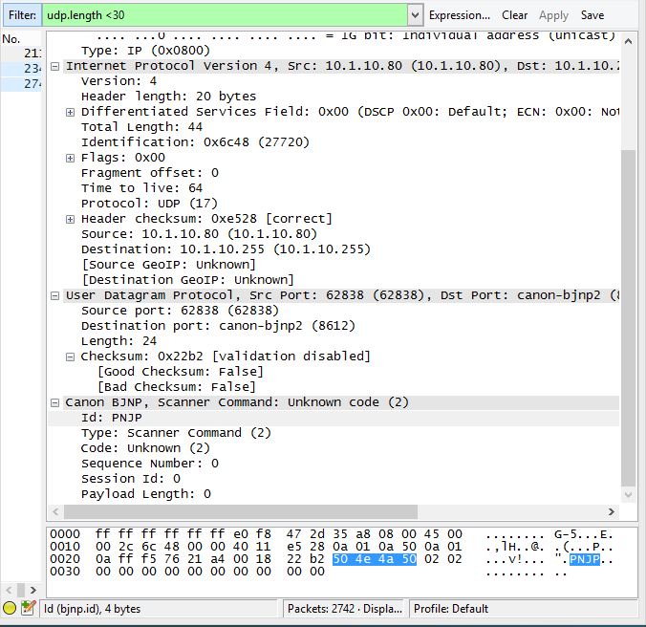

6. Hands-on Practice I: TCP (10 pts)

In this practice, we’ll investigate the behavior of TCP in detail. Before beginning our exploration of TCP, we’ll need to use Wireshark to obtain a packet trace of the TCP. You’ll do so by accessing:

http://www-users.cselabs.umn.edu/classes/Spring-2014/csci4211/HTTP-2.htm

First, filter the packets displayed in the Wireshark window by entering “tcp” into the display filter window towards the top of the Wireshark window. What you should see is series of TCP and HTTP messages between your computer and

Please answer the following question (along with screenshots as the evidence of your answer)

- What is the IP address and TCP port number used by the client computer (source) that downloads the bill of rights from www-users.cselabs.umn.edu? You need to paste an appropriate screenshot as the evidence. (2pts)

The client computer (mine) has IP&Port: 10.1.10.57:16700. I used from 14 for this.

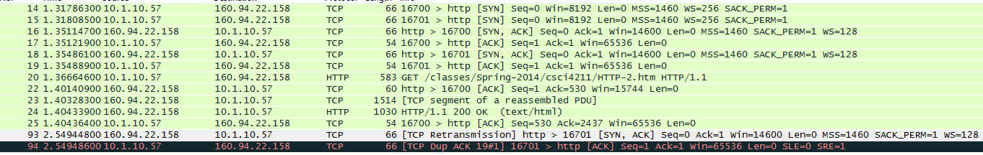
The screenshot below has all captured packets for question 6. All answers reference this photo. If there are exceptions, an additional photo will be embedded.

Since this lab is about TCP rather than HTTP, let’s change Wireshark’s “listing of captured packets” window so that it shows information about the TCP segments containing the HTTP messages, rather than about the HTTP messages. To have Wireshark do this, select Analyze->Enabled Protocols. Then uncheck the HTTP box and select OK. You should now see a Wireshark window that looks like:

Please answer the following question (along with screenshots as the back-up evidence of your answer, if applicable)

- What is the sequence number of the TCP SYN segment that is used to initiate the TCP connection between the client computer and the webserver? What is it in the segment that identifies the segment as a SYN segment? (2pts)

The seq# for the initial SYN (not the SYN, ACK) segment is 0. There is a flag bit set in the TCP section of Wireshark. This is in frame 14.

- What is the minimum amount of available buffer space advertised at the received for the entire trace? Does the lack of receiver buffer space ever throttle the sender? (2pts)

The minimum amount of buffer space as advertised by the first ACK is 14600 bytes. This is in frame 16: “Win=14600”

- Are there any retransmitted segments in the trace file? What did you check for in order to answer this question? (2pts) You need to paste a screenshot as the evidence.

Yes, from 93 is a retransmitted packet. I looked for the phrase “TCP Retransmission,” additionally the out of order sequence number. I also have a Dup ACK error.

- Based on the sequence number, you can calculate how many bytes (TCP payload) have been transferred through this TCP connection. Does the number of total bytes downloaded through this TCP connection equal to the html file size of the bill of rights? Explain why? (2 pts)

No, the number of bytes do not match. This is because each packet as overhead and is not only the HTML data.

7. Programming Assignment: Network performance measurement via socket programming (30 pts.)

Requirements and suggestions (must read!)

- This problem requires building one server and one client application which exchange packets over UDP and TCP. Via packet exchange, we will measure the performance of the network path between two hosts.

- You are free to use any language and your applications can have any function, as long as they can provide the information needed in answering the questions. However, efficient design will help you to save your time in measuring & answering questions.

- During implementation, it is recommended to run both the server and client on one machine using loopback, as it greatly helps the debugging process. (However, note that Wireshark cannot capture packets on loopback)

- When it comes to actual measurement, server and client should at least be 3 hops away from each other. (i.e., at least 2 intermediate routers) You are free to use any two machines satisfying this condition. Our suggestion is to use two CSE lab machines as described below.

● Server: Linux/Unix machine in Keller hall CSE labs
One candidate would be apollo.cselabs.umn.edu
Entire list of such machines is at http://cselabs.umn.edu/labs/unix_machines
● Client: Windows machine in CSE lab in Walter library 103
Candidates are: w103-01.cselabs.umn.edu to w103-29.cselabs.umn.edu
Please be aware that these machines might not have compilers installed.
So be ready to compile elsewhere!

- For ease of measurement, all the measurement should be done on the client side.

- When providing Wireshark screenshot, please delete any unrelated packets from the packet list by right click - Ignore Packet

- For timing observation in Wireshark, please see Arrival Time under Frame info.

- Make sure your firewall is set accordingly.

TCP performance measurement

Build server and client applications that can communicate over TCP.
Remember, you are free to implement them as you wish, but efficient design can help you to save your time in answering the questions. Therefore, understanding the questions in prior to implementation is recommended. Recall that all the measurement below should be done on the client side.

- Show the network path between server and client. Note that they need to be at least 3 hops apart. Please provide screenshot of traceroute as well as a table including all the IP addresses on the path (including client and server) (5 pts)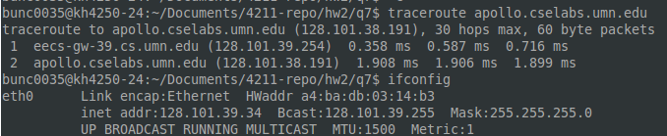

- Using Wireshark, observe the TCP connection establishment process (namely, three way handshake). Repeat 5 times and provide the average time taken for connection establishment. Ignore the time for the last ACK in three way handshaking to reach the server, as this cannot be measured from the client side.

Simply put, the establishment time is defined as the duration from when "synchronize" (SYN) segment (first segment) was sent out from the client until when ACK (third segment) was sent out from the client (in response to SYN & ACK segment (second segment) from the server.

Also please provide a screenshot of Wireshark showing TCP connection establishment. (5pts)

- Using Wireshark, observe the TCP connection termination process, initiated by the client. Repeat 5 times and provide the average time taken for connection termination. Ignore the time for the last ACK to reach the server, as this cannot be measured from the client side.

Simply put, the establishment time is defined as the duration from when FIN segment (First segment) was sent out from the client until when ACK (fourth segment) was sent out from the client in response to FIN segment (third segment) from the server.

Also please provide a screenshot of Wireshark showing TCP connection termination. (5pts)

- Send precisely 10,000,000 bytes of application data to the server via TCP. Once the client finishes its data transmission, the server shall send an application-level acknowledgement. Use your program (instead of Wireshark) to measure the time between the start of the client-side transmission and the reception of the application-level acknowledgement. (3pts)

I could not figure out how to record the rtt. I attempted to simple have it record the time, but the Net::time module was not available/not compiling on the CSE lab machines.

My code sends files, but I have to use wireshark to measure this. The time calculations were also done by hand.

Connection at: 00:00:00.0000
Start of File Transmission at: 00:00:00.0023
End of File Transmission at: 00:00:01.2598

UDP performance measurement

This time, build server and client applications that communicate over UDP.
Answer the following using the server and client.

- Use your own program to measure RTT (Round Trip Time) of UDP. Sending 10 UDP datagrams from client to server, where server immediately reply with a UPD datagram every time when it receives a datagram from client. RTT can be obtained by computing the time from a datagram was sent out from client until when the corresponding reply was received by the client.

Please provide the average, minimum, and standard deviation of Round Trip Time and a screen shot of 10 UDP exchanges. (5pts)

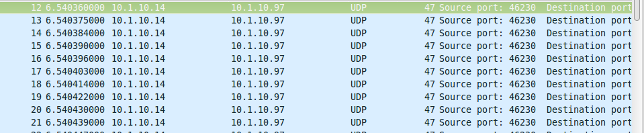

AVG = 0.0000413s for 10 packets
min = 0.0000010s
max = 0.0000100s

- Send precisely 10,000,000 $2.25×{10}^{6}$bytes of application data to the server via UDP. Let server ignore the packet loss. Use your program (instead of Wireshark) to measure the time between the start and end of the client-side transmission. (Unlike question d, application-level acknowledgement is NOT required) Compare the result with the TCP case in question d. Explain the difference in delay. (7pts)

Connection at: 00:00:00.0000
Start of File Transmission at: 00:00:00.0000
End of File Transmission at: 00:02:18.7770

The difference is how I sent them. In TCP, I made a bytestream with a handshake, this way I sent a steady stream of data from the file I want delivered. UDP was different and harder to implement, I only send 4 bytes at a time and the server is bombarded. It is not very efficient and takes much longer to receive the whole file, or at least 10MB of it.

Submission guidelines

- Zip and submit all source codes used in this problem along with your solution.

- Please provide a brief readme file (need not be in detail) containing short descriptions on each source file, how your code works, and instructions on compiling and running.

